2016

VeriHandy UI Design Document

Built for Shawn Squire

VeriHandy Development Team

Anil Kendir – Team Facilitator

Matthew Wheeler – Requirements Leader

Justus Jackson – Implementation and Testing Leader

Dean Fleming – Design Leader

Tristan Adams – Delivery Leader

VeriHandy

User Interface Design Document

#### Table of Contents

Page

## 1. Introduction

* 1. Purpose of This Document
  2. References

2. User Interface Standards

3. User Interface Walkthrough

4. Data Validation

5. Report Formats

Appendix A **-** Agreement Between Customer and Contractor

Appendix B – Peer Review Sign-off

Appendix C – Document Contributions

## 1. Introduction

1.1 Purpose of This Document

This document outlines and explains VeriHandy’s User Interface. It will explain the design standards, walkthrough the navigation of the website, explain how data is validated, and explain the format of reports.

* 1. References

W3Schools – [www.w3schools.com](http://www.w3schools.com) – Used as a resource for learning HTML and CSS code for the development team

1. **User Interface Standards**

This section will discuss the standard components of the VeriHandy website.

For the login page, the user will be shown our logo, a box for username and password, and a login button (Figure 1.0). Input will be validated in these boxes.

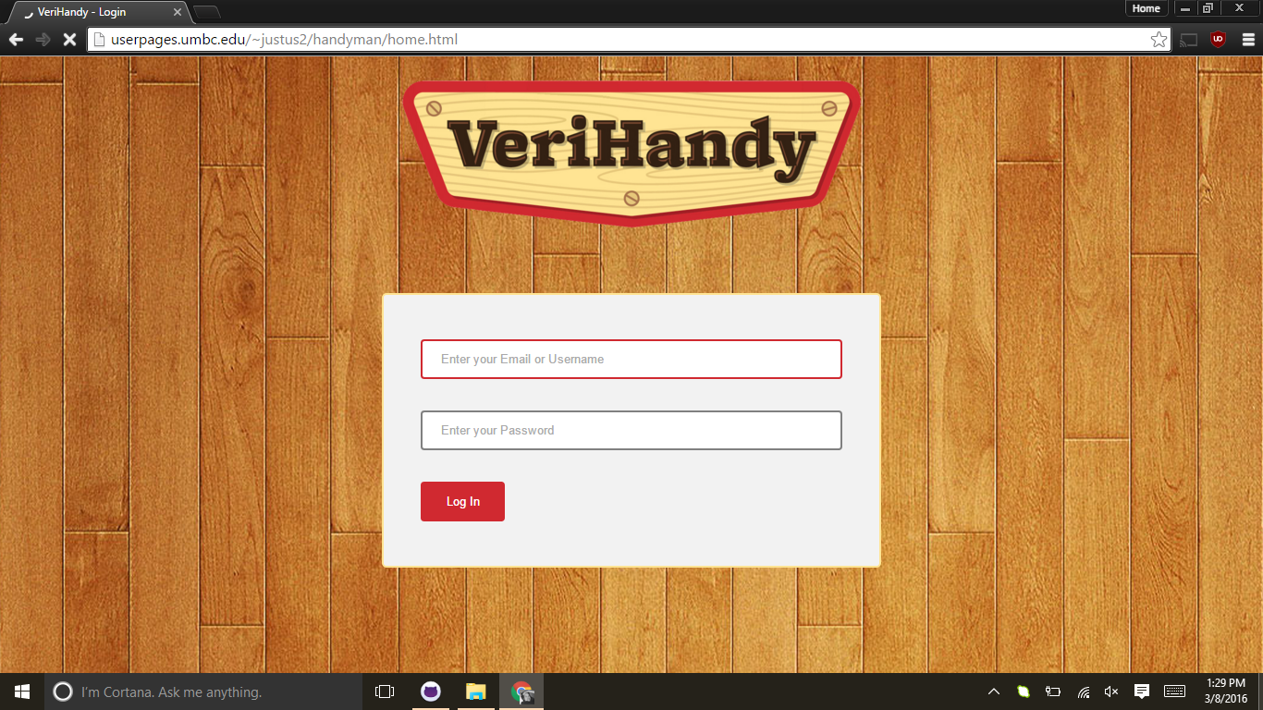

Figure 1.0

1. **User Interface Walkthrough**
   1. – Navigation Diagram

To be added when we have enough pages developed.

* 1. – Walkthrough
* 3.2.1 – Logging In
  + The user attempts to enter their username and password. If either are left empty, there will be a pop up stating so (see figures 2.0 and 2.1)

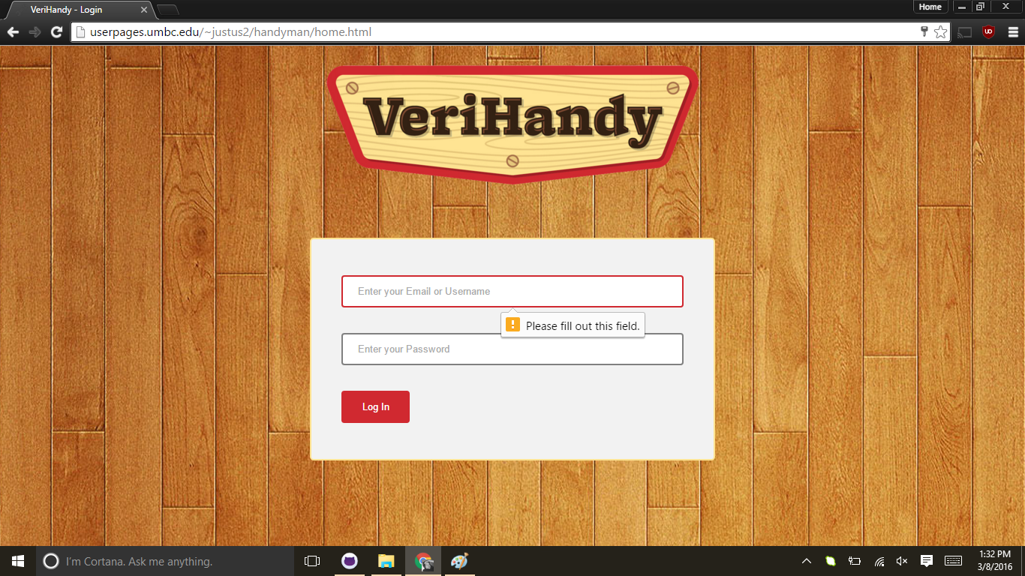

Figure 2.0

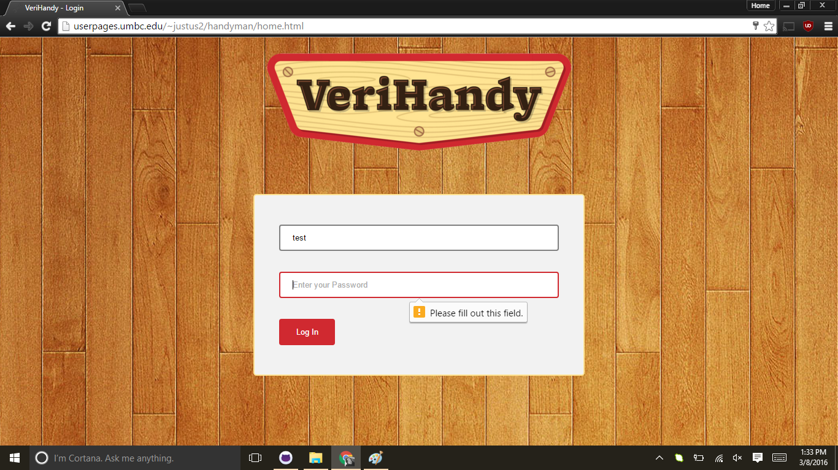

Figure 2.1

* + If the password is not in the correct formatting (for users who are creating a new account), a pop up displays saying so (see Figure 2.2). Correct formatting is at least 8 characters, one of which is a number.

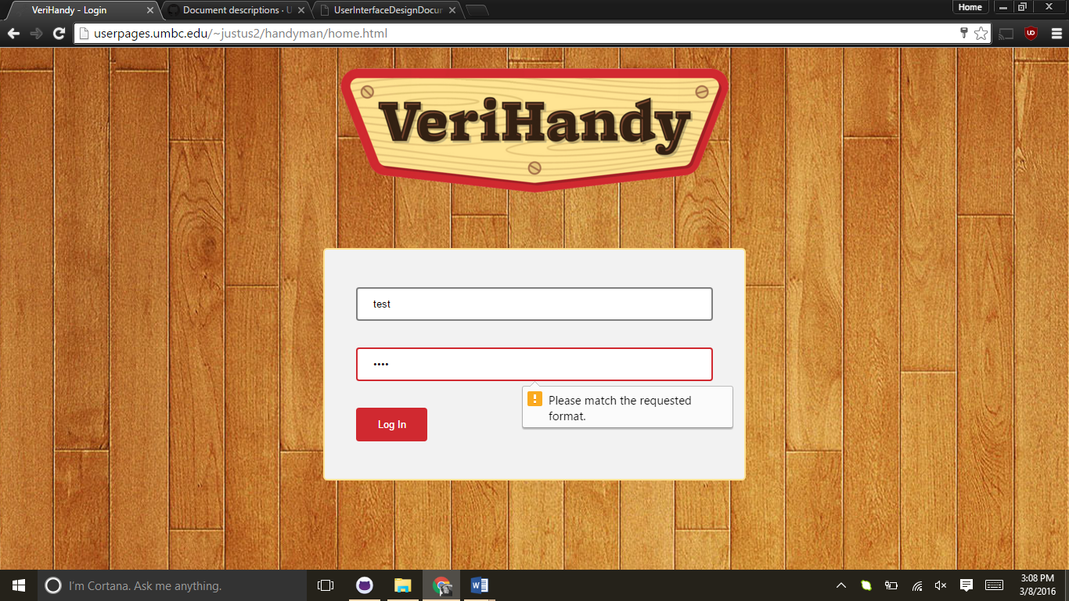

Figure 2.2

* + Once a user hits the Log In button and everything is correct, they are taken to a redirect page, which then would allow them to access the site (see Figure 2.3).

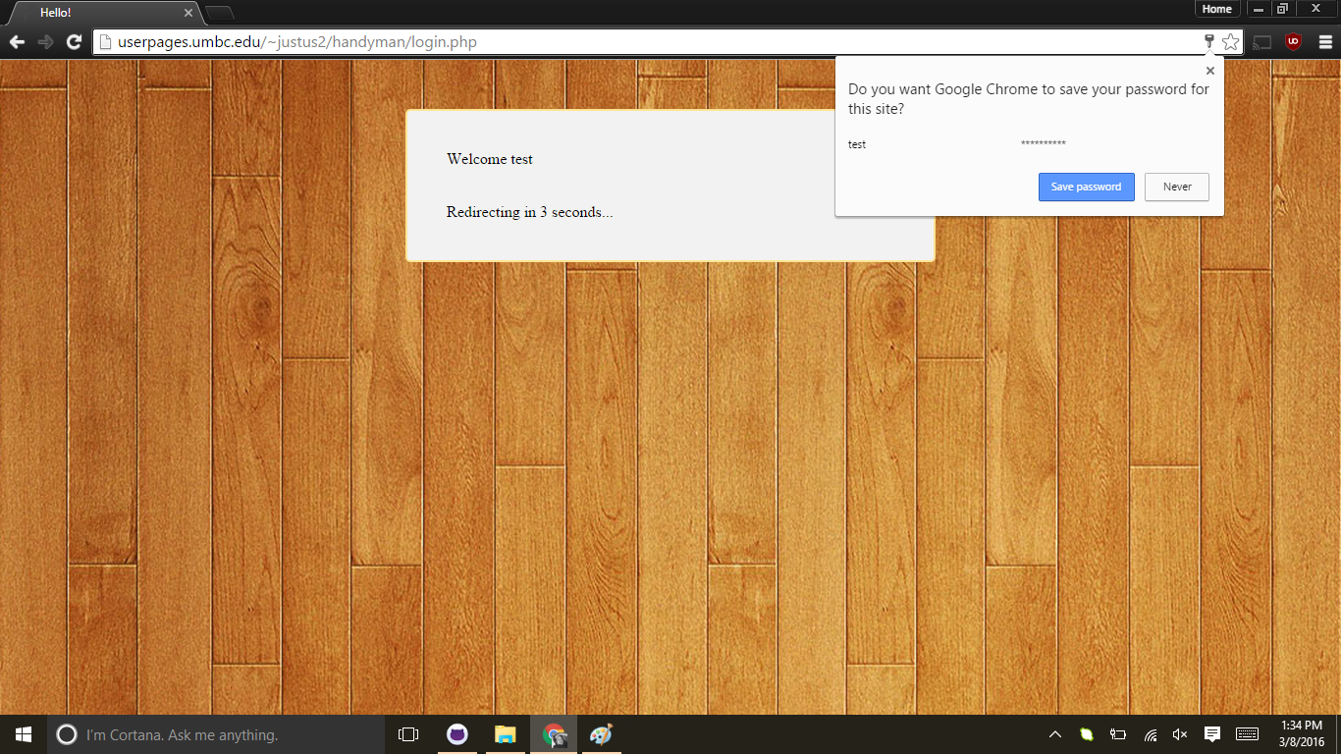

Figure 2.3

1. **Data Validation**

|  |  |  |
| --- | --- | --- |
| **Entry Location** | **Data Type** | **Limits** |
| Username Box | String | Must not already be in use if creating a new user |
| Password Box | String | Must be at least 8 characters and contain at least one number |

1. **Report Formats**

None yet

**Appendix A – Agreement Between Customer and Contractor**

In case of future changes to be made to the project/requirements, The following procedure will be used:

1. Mr. Shawn Squire and the VeriHandy Development Team, consisting of at least the Facilitator, Anil Kendir, and 2 other Team Members based on availability, will meet to discuss changes to be made to the requirements
2. Ideas, progress, and changes will be discussed between the Development Team and Mr. Shawn Squire and a new agreement will be reached
3. The Development Team will revise this and other documents and update them as necessary.
4. A full set of signatures from Shawn Squire and the Development Team indicates that Mr. Shawn Squire and the Development Team agree on the requirements listed and design and development can proceed.

Customer Comments:

---------------------------------------------------------------------------------------------------------------------

Signatures:

Shawn Squire: _____________________________________ Date: ___________________

Anil Kendir: _______________________________________ Date: ___________________

Team Member: _____________________________________ Date: ___________________

Team Member: ______________________________________ Date: ___________________

Team Member: ______________________________________ Date: ___________________

Team Member: ______________________________________ Date: ___________________

**Appendix B – Team Review Sign-off**

Signatures here indicate that all members of the team have reviewed and agreed upon the document’s content and format.

Team Comments:

---------------------------------------------------------------------------------------------------------------------

Signatures:

Shawn Squire: _____________________________________ Date: ___________________

Anil Kendir: _______________________________________ Date: ___________________

Matt Wheeler: _____________________________________ Date: ___________________

Justus Jackson: ______________________________________ Date: ___________________

Dean Fleming: ______________________________________ Date: ___________________

Tristan Adams: ______________________________________ Date: ___________________

**Appendix C – Document Contributions**

Dean Fleming

* Created document, put all information regarding the login and redirect pages.

Justus Jackson

* Created the login and redirect pages seen in the screenshots

Tristan Adams

* Created the Title and Appendix pages